Experiment No: - 06
Experiment Name:- FTP Server and SMTP (POP3 and IMAP) using Cisco Packet Tracer.
Aim: The aim of this report is to understand and implement the FTP Server and SMTP (POP3 and IMAP) using Cisco Packet Tracer.

Objectives:
- To learn about Cisco Packet Tracer.
- To implement a FTP Server using Cisco Packet Tracer.
- To implement SMTP (POP3 and IMAP)

Working Procedure: (FTP)

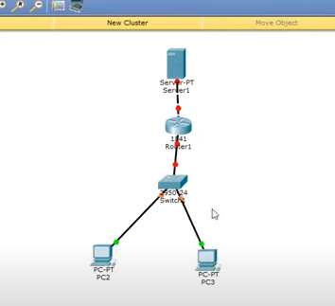

Turn on Port Status and Assign IP to router’s both interfaces
FastEthernet0/0 (Connects with server):
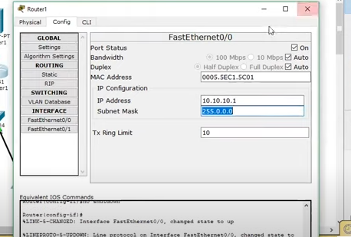
FastEthernet0/1(Connects with switch)
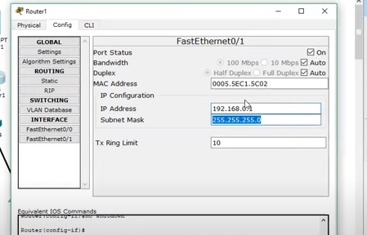
Now Assign IP Addresses and their respective gateways to PC’s
PC 01:
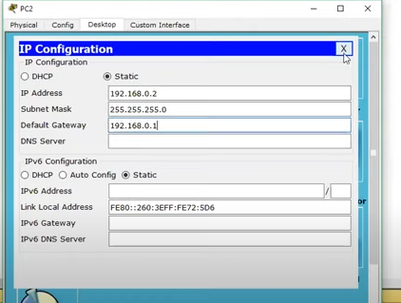
PC 02:
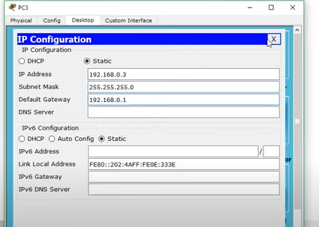
Now Assign IP Address and default gateway to Server:
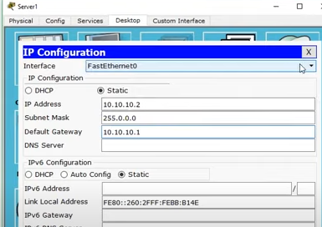
Now we need make sure that server can also act as a FTP server (Follow the following steps):
Click on the server
If you want to change the display name click on config and change the display name.
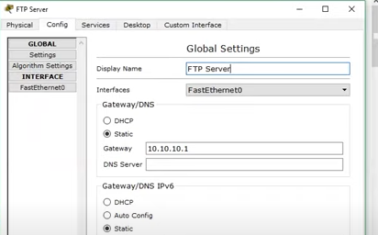
Click on the services FTP Here make a user
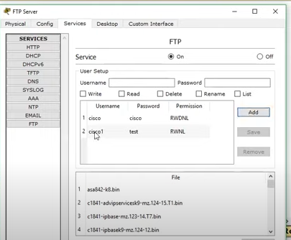
Now to check whether our FTP services are fine or not:
First of all upload a file on the server from the PC and for this make a file.
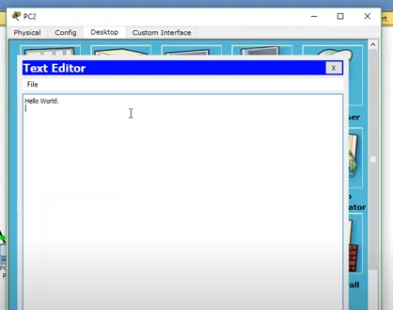
Save this file.
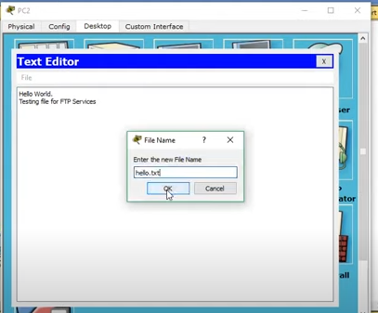
Then go to command prompt and ping with server
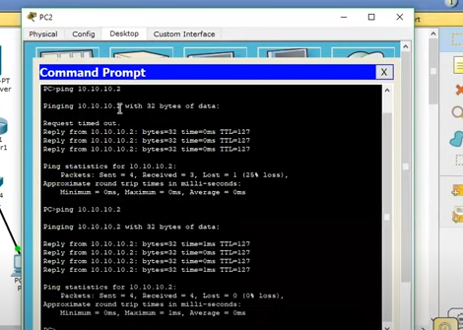
Now Access the FTP Server and upload File on the server
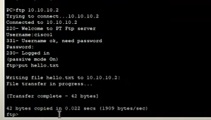
To check it you need to check the directory (use command “dir”)
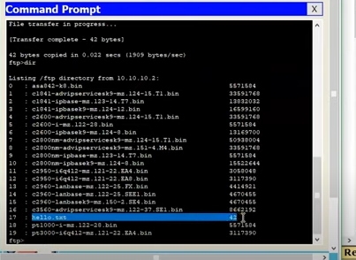

Now to Download the file click on the 2nd PC
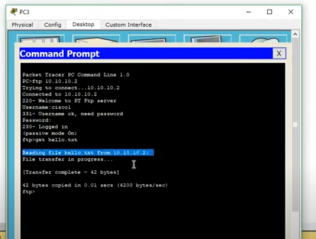

Working Procedure: SMTP (POP3 and IMAP)

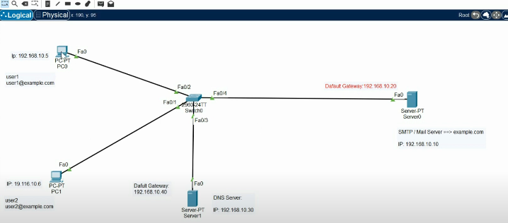

Assign Addresses to PC 01:
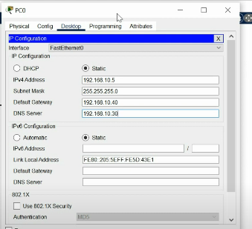
Now configure email setup for PC 01:
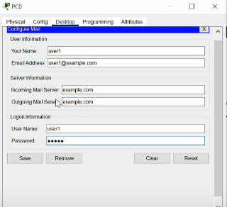
You get the following interface
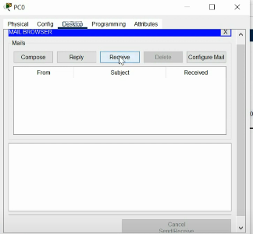

Similarly do configuration for PC 02 (give addresses as shown in 1st Figure)
Now Configure DNS server
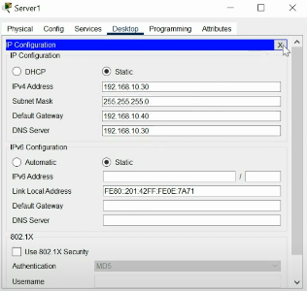
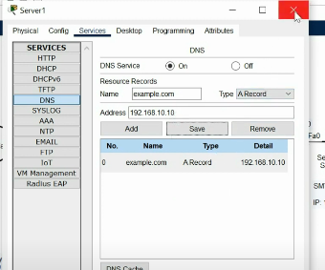

Now configure Email Server
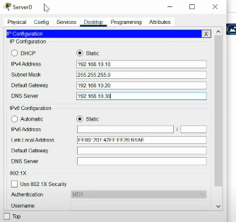
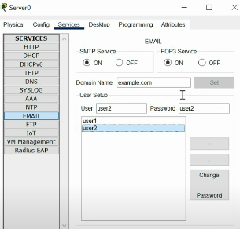

Now test it by sending mail from PC 01 to PC 02
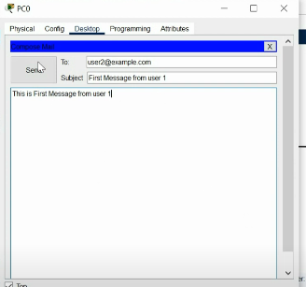
On receiving send you will receive email
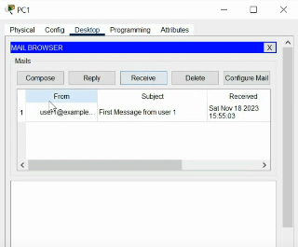

Experiment 02:
Set the telnet password on Cisco:
Access the cisco router remotely by VTY lines, these are the Virtual Terminal lines for access router, you can set password on these line by using the following commands:
Router(config)#line vty 0 4
Router(config-line)#password Cisco
Router(config-line)#no login
Above command will set the telnet password to “Cisco”.
Set the IP address to Cisco interface:
Set the IP address to any Cisco device interface by using the following commands:
Router(config)#interface <interface name&number>
Router(config-if)#ip address <IP address> <subnet mask>
Save the configurations:
You can use the following command for router configuration to Nvram for use at next boot up
Router#copy running-config startup-config
Configure the access-list on Cisco:
configure the access-list on cisco by using following commands:
Router(config)#Access-list <number> <permit|deny> <ip> <mask>
Router(config-if)#ip access-group <number> <in|out>
OR
Router(config)#Access-list <number> <permit|deny> <protocol> <from ip and mask> <to ip and mask> <port number>
Router(config-if)#
Command Example:
Router(config)#access-list 2 deny 192.168.0.33 0.0.0.255
Router(config)#interface fastEthernet 4/0
Router(config-if)#ip access-group 2 in
How to configure the default route on Cisco:
Following command will set the default route to 10.10.10.101.
Router(config)# ip route 0.0.0.0 0.0.0.0 10.10.10.101
Create a static route on Cisco router:
Router(config-router)#ip route [destination_network] [mask] [next-hop_address
you can set a static route by using above command example is also given below:
Router(config-router)#ip route 192.132.23.1 255.255.255.0 10.10.10.1
Conclusion: From the lab we learn about CLI commands and working principle and get extra knowledge about CISCO Packet Tracer.

